Nama : Iqbal Subekhan

NIM : 18090006

Kelas : 5A

**PRAKTIKUM 2**

1. Source Code

latihan1-> application/controller

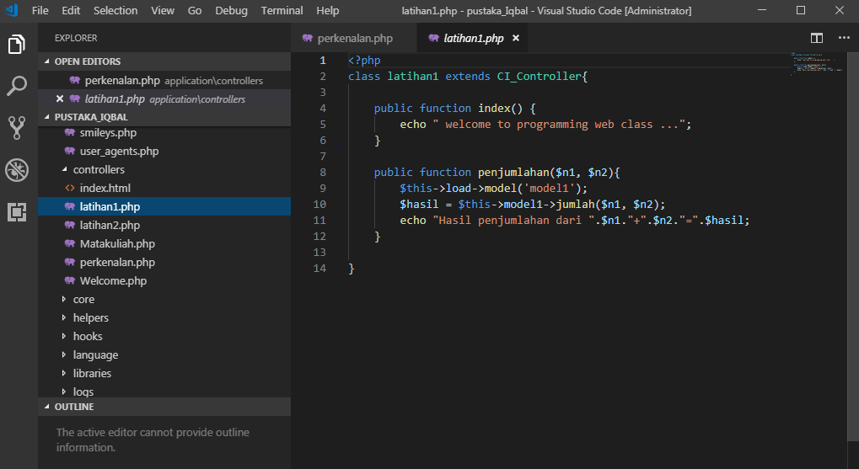

latihan2 -> application/controller

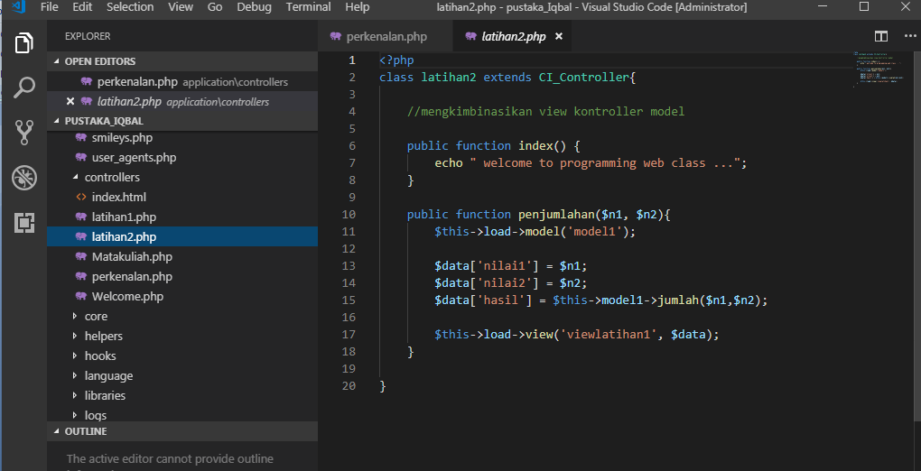

model1 -> application/model

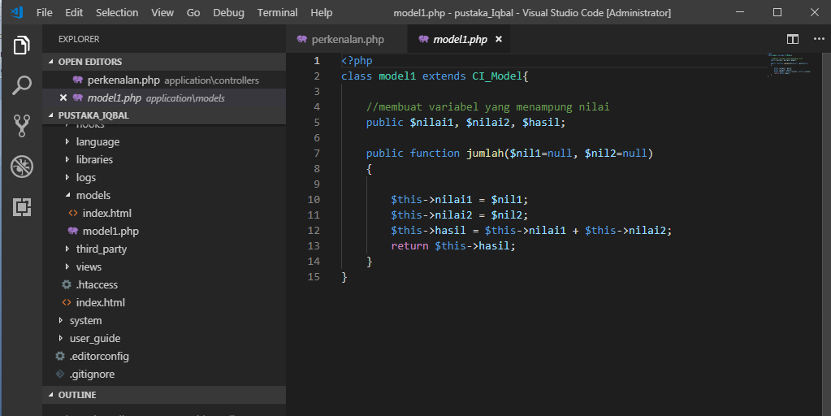

viewlatihan1.php->application/view

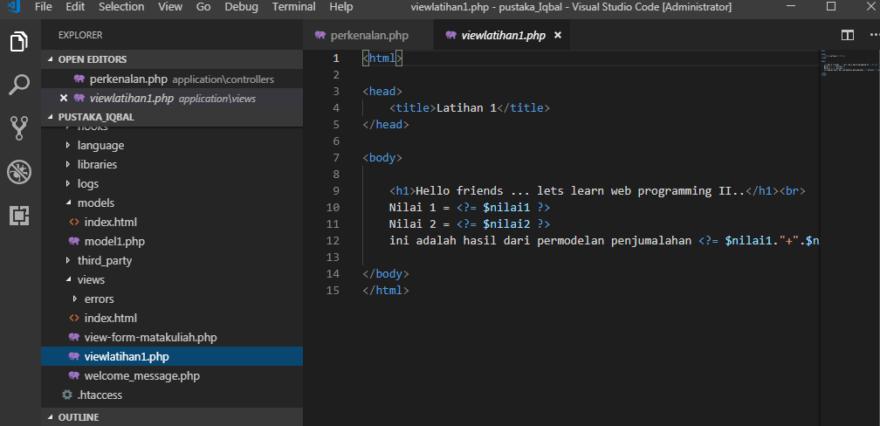

1. URL

<http://localhost/pustaka_Iqbal/index.php/latihan2>/

<http://localhost/pustaka_Iqbal/index.php/latihan2/penjumlahan/1/6>

<http://localhost/pustaka_Iqbal/index.php/latihan1/penjumlahan/4/5>

1. Capture Hasil

Hasil run latihan 2

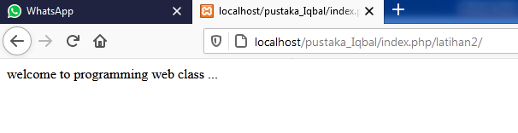

**Hasil run penjumlahan**

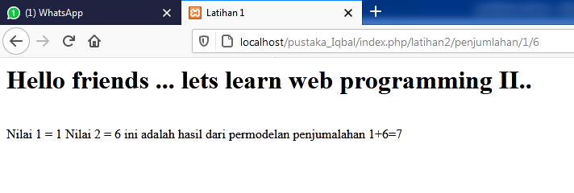

**Hasil run latihan1**

